MAKERERE COLLEGE SCHOOL
S1. BOT TERM II 2010
MATHEMATICS

DURATION: 1 HOUR. 30 MINUTES.

Instruction: Answer all questions.

1 . Evaluate: 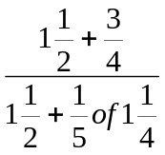.

2. Find the L.C.M and H.C.F of 18, 45 and 36.

3. Express the recurring decimal 1.03636 …… as a fraction I its lowest terms.

4. Evaluate 127.5 - 31.002 + 42.5 - 9.998 to 2 significant figures.

5. How many packets of tea weighing 0.25kg can be obtained from 60kg of tea ?

6. Mr. X spent ¼ of his salary on School fees, ½ of the remainder on transport.
He saved 72,000 shillings. Find how much Mr. earns as salalry.

7. Find the exact value of 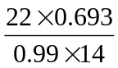 without using a calculator .

8. Write down the prime numbers between 60 and 75.

9. A number when divided by 5 leaves remainder 4. The same number divided
by 8 leaves remainder 7.

10. (a) Correct the numbers to significant figures (sf) given.
(i) 159.46 (2sf)
(ii) 1.8089 (1sf)
(iii) 39.97 (3sf)

- Write the number in standard form.

- Write the following numbers to the given decimal places (dp).

(i) 0.0092598 (4dp)
(ii) 41.6972 (2dp)
(iii) 7.0448 (1dp)
(iv) 8799,9954 (3dp)
****

